WHATSNEXT VISION MOTORS
SALESFORCE CRM PROJECT
Project Documentation
Name: P. Jahnavi
Roll No.: 23P61A3245
Branch & Year: CSB - 4th Year
Salesforce Trailhead Profile:
https://www.salesforce.com/trailblazer/dyjyzvcoc58m0ilgdf

1. Project Overview
WhatsNext Vision Motors is a Salesforce-based Customer Relationship Management (CRM) application designed to manage vehicle inventory, dealer information, customers, vehicle orders, test drives, and service requests. The project demonstrates Salesforce data modeling, Lightning application development, Flow automation, Apex programming, Batch Apex, and Scheduled Apex.
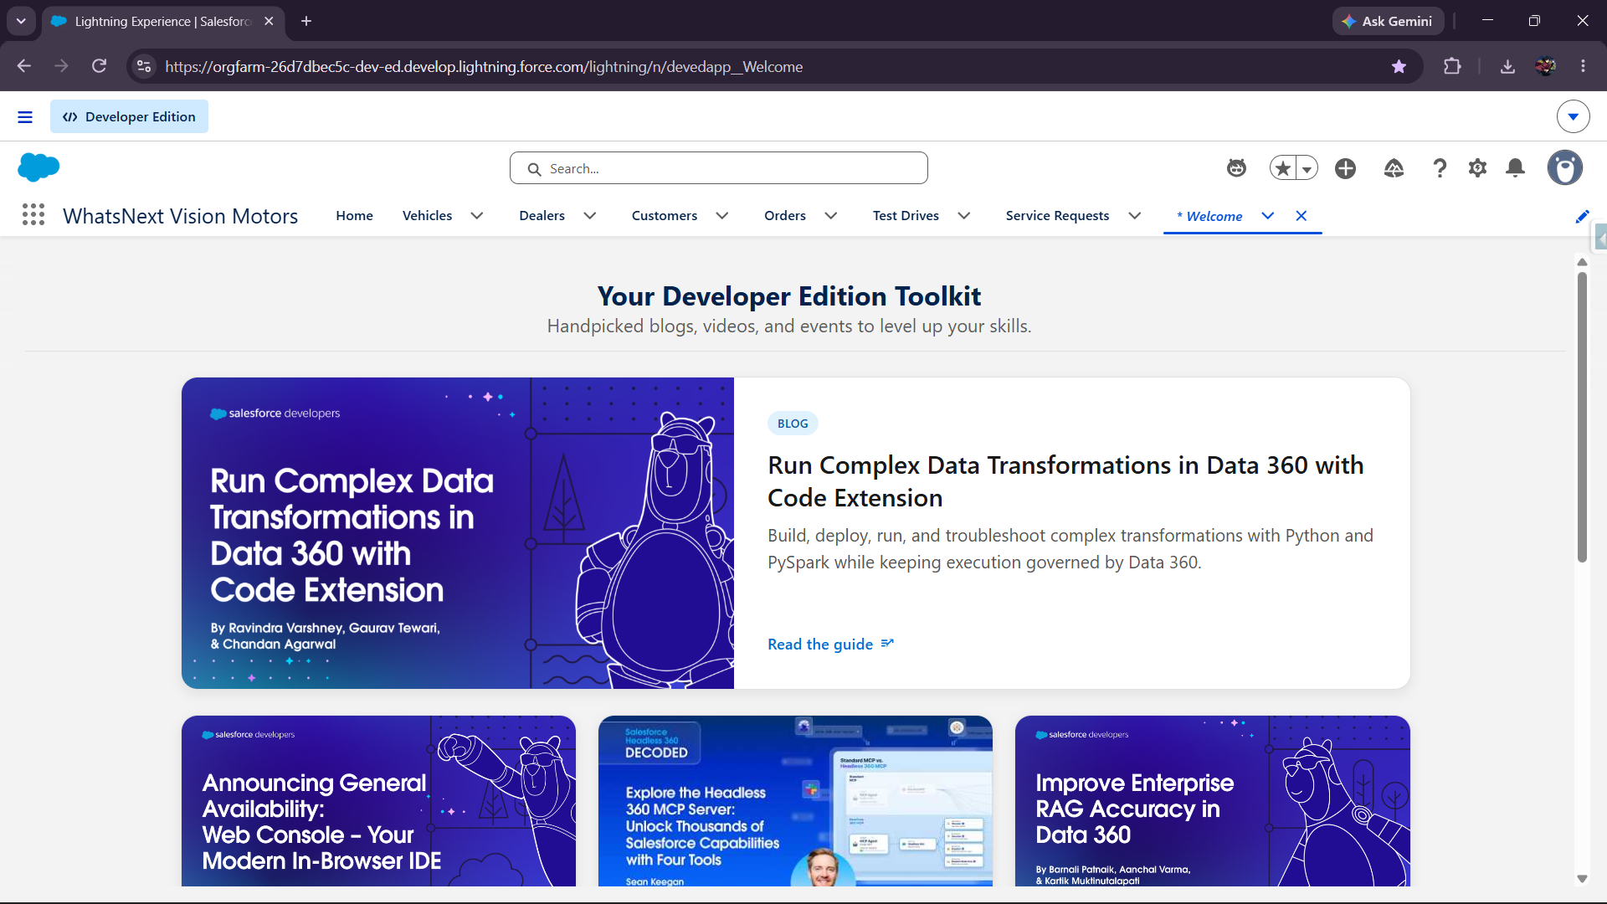

2. Problem Statement
Vehicle dealerships need an organized system to manage vehicle stock, customer information, dealer details, orders, test drives, and service requests. Manual processing can result in incorrect orders, delayed follow-ups, and difficulty identifying the appropriate dealer. This project addresses these requirements using Salesforce CRM and automation.

3. Objectives
- Create a centralized Salesforce CRM application for vehicle dealership operations.
- Maintain vehicle details and real-time stock availability.
- Store dealer information including location details.
- Manage customer information and contact details.
- Create and process vehicle orders.
- Prevent customers from ordering vehicles that are out of stock.
- Automatically assign the nearest dealer based on customer and dealer location.
- Send automated reminders for scheduled test drives.
- Automatically update service request status.
- Periodically synchronize vehicle availability using Batch Apex and Scheduled Apex.
- Automatically process pending orders when vehicle stock becomes available.
- Send scheduled notifications for stock replenishment and pending order processing.

4. Project Requirements

4.1 Functional Requirements
- Vehicle Management – Create and maintain vehicle model, brand, price, stock quantity, and availability.
- Dealer Management – Maintain dealer name and location information including city, state, street, latitude, and longitude.
- Customer Management – Store customer name, address, phone, email, and location information.
- Order Management – Create orders with customer, vehicle, dealer, quantity, date, status, and total amount.
- Stock Validation – Block an order when the selected vehicle has zero stock.
- Nearest Dealer Assignment – Automatically select the nearest dealer using customer and dealer latitude/longitude.
- Test Drive Management – Schedule test drives and maintain customer, vehicle, dealer, date/time, status, and reminder information.
- Test Drive Reminder – Send an automated email reminder one hour before a scheduled test drive.
- Service Request Management – Create service requests and automatically move the status to In Progress.
- Vehicle Stock Batch Processing – Periodically update vehicle Availability based on Stock Quantity.
- Order Status Processing – Change pending orders to Confirmed when stock is available.
- Scheduled Notifications – Send notifications for out-of-stock vehicles and pending orders.

4.2 Non-Functional Requirements
- The application should be easy to use through Salesforce Lightning.
- Data should be organized using appropriate Salesforce objects and relationships.
- Automation should reduce manual processing.
- Apex logic should be reusable through a trigger handler.
- Batch processing should support multiple records efficiently.
- The system should provide clear validation messages for invalid orders.

5. Technologies Used
- Salesforce CRM
- Salesforce Lightning App Builder
- Salesforce Objects, Fields and Relationships
- Record-Triggered Flows
- Apex
- Apex Triggers and Trigger Handler
- Batch Apex
- Scheduled Apex
- SOQL
- Salesforce Email Automation

6. Salesforce Application
A Lightning application named WhatsNext Vision Motors was created with navigation for Home, Vehicles, Dealers, Customers, Orders, Test Drives, and Service Requests.
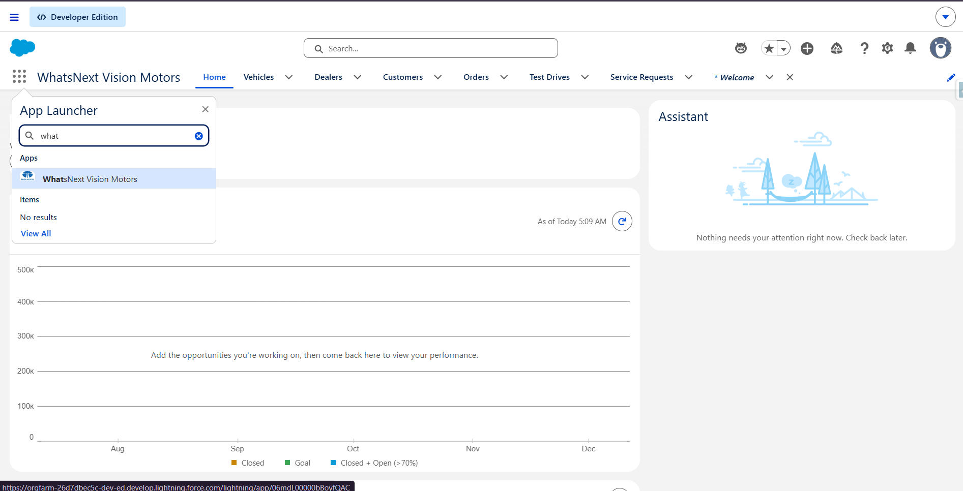

7. Data Model
The project contains the following major custom objects:
- Vehicle
- Dealer
- Customer
- Order
- Test Drive
- Service Request
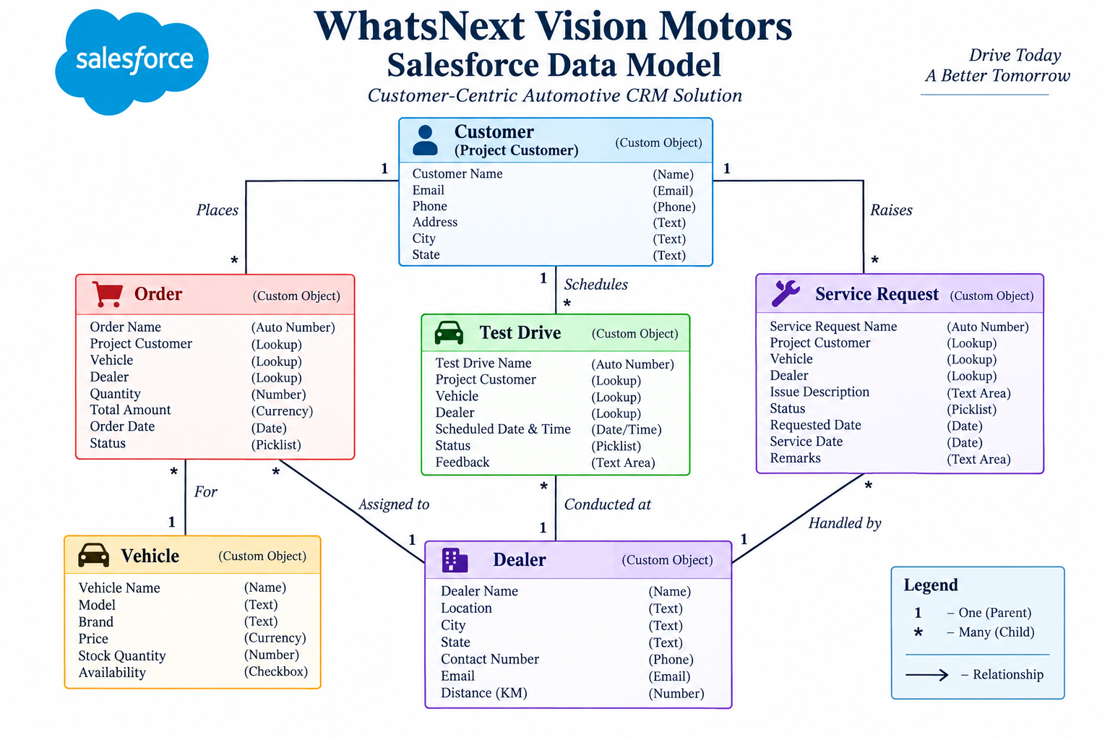

8. Object and Field Details

Vehicle
- Model
- Brand
- Price
- Stock Quantity
- Availability
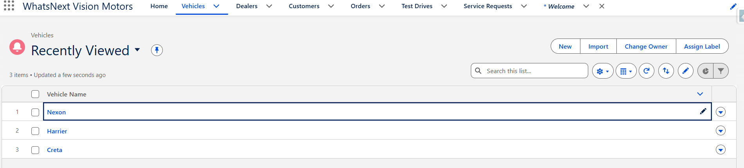

Dealer
- Dealer Name
- City
- State
- Street
- Latitude
- Longitude

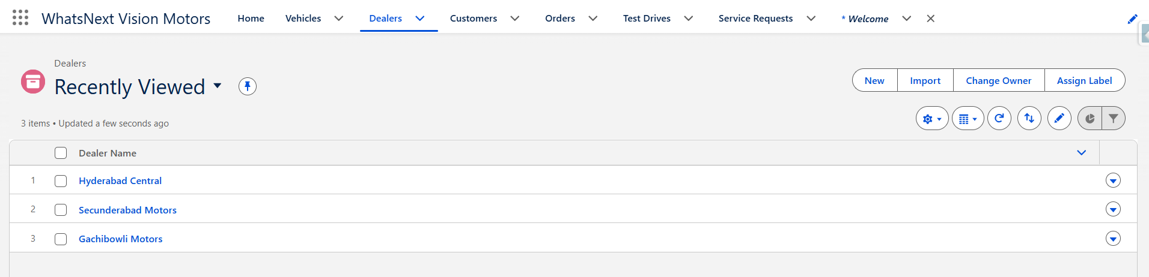

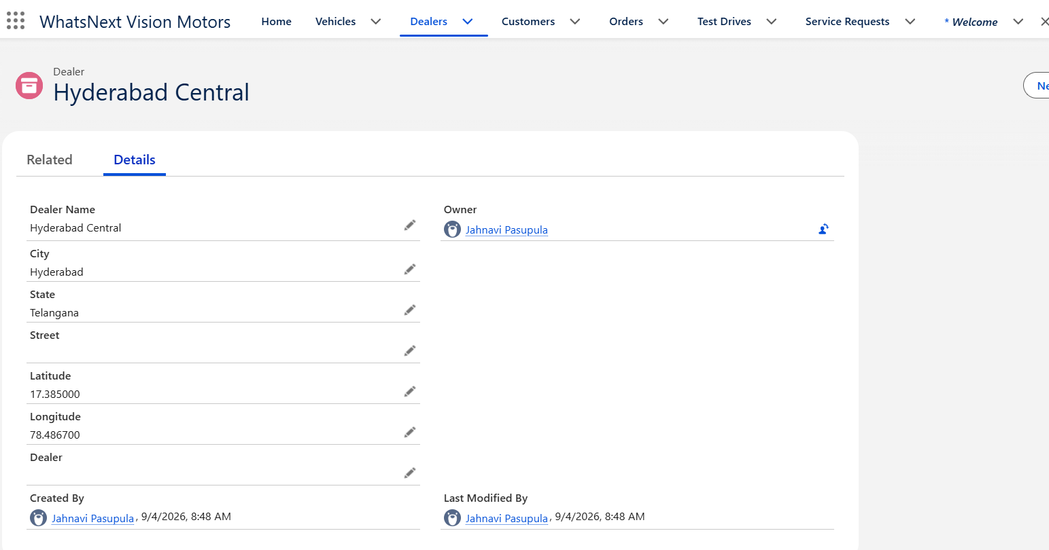Customer
- Customer Name
- Street
- City
- State
- Postal Code
- Latitude
- Longitude
- Phone
- Email
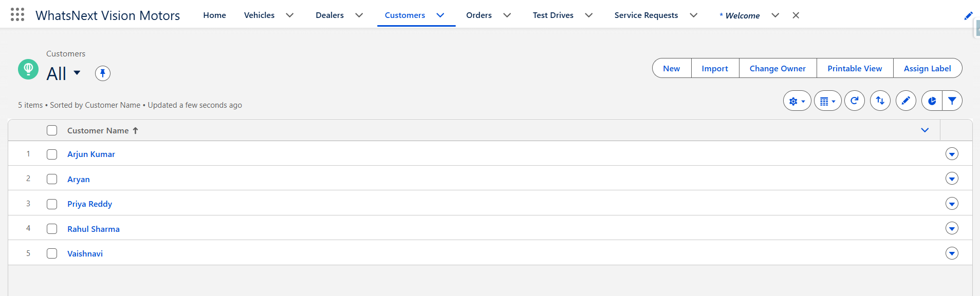
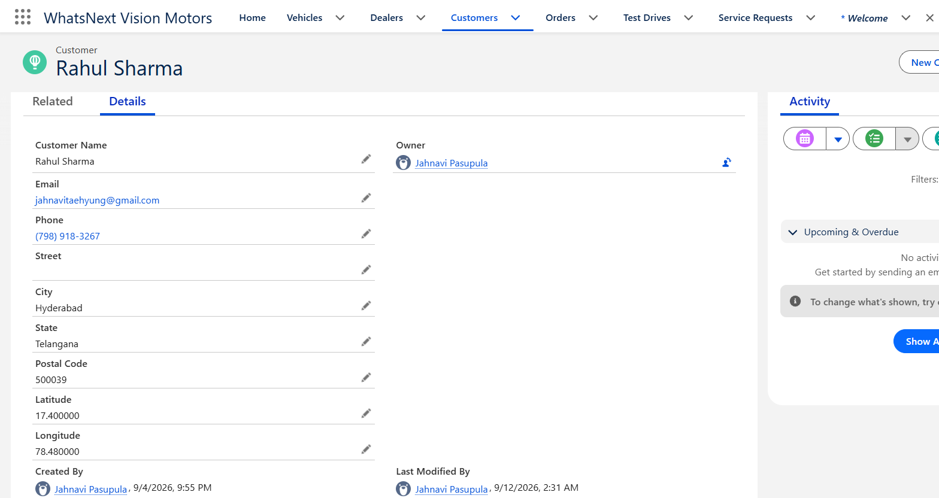

Order
- Order Number
- Project Customer
- Vehicle
- Dealer
- Quantity
- Order Date
- Status
- Total Amount
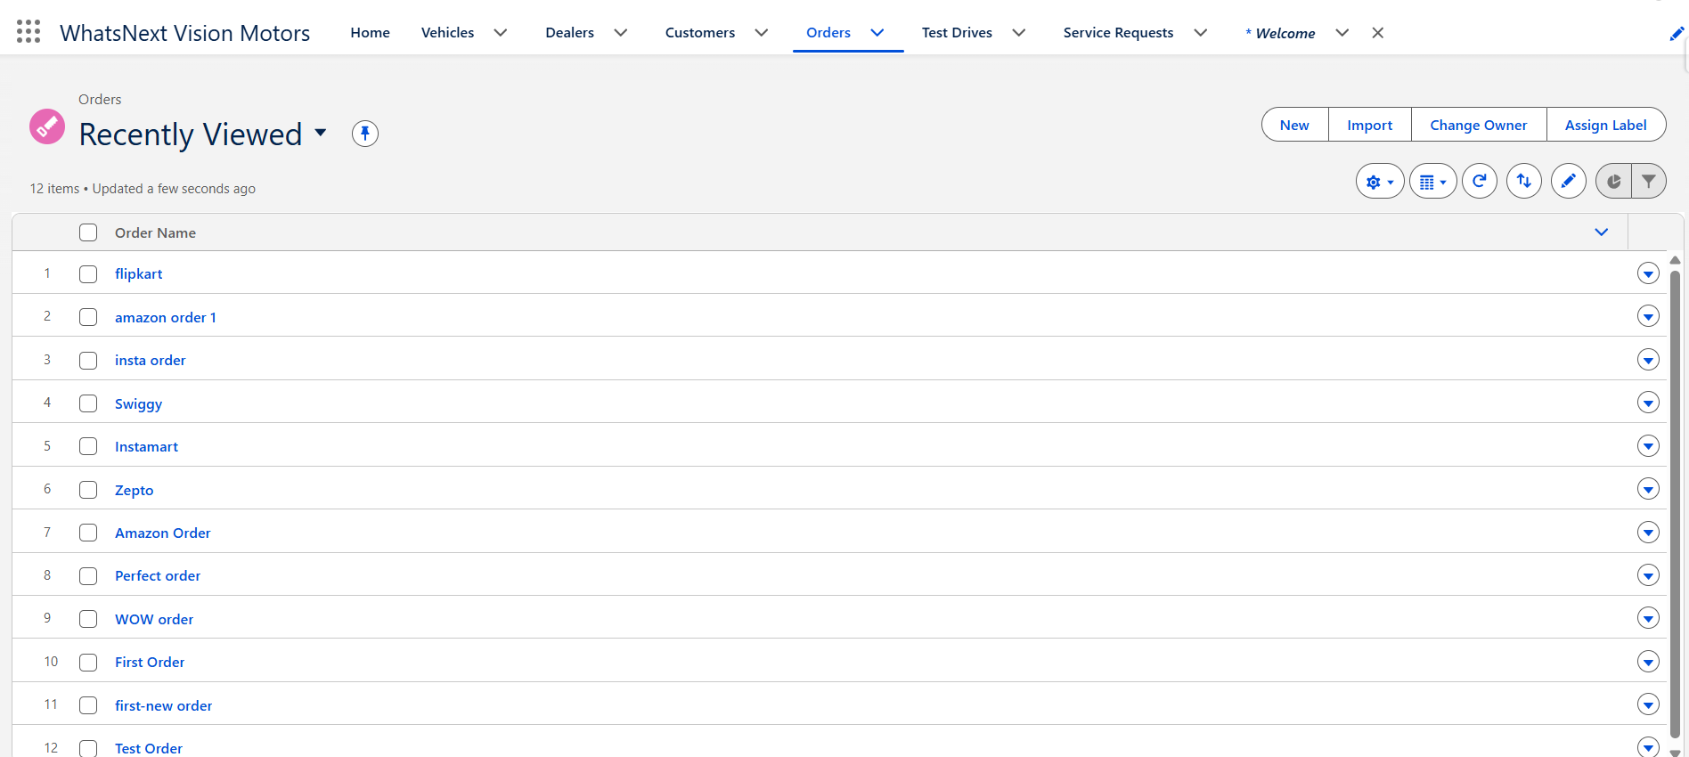

Test Drive
- Test Drive Number
- Project Customer
- Vehicle
- Dealer
- Scheduled Date & Time
- Status
- Reminder Sent
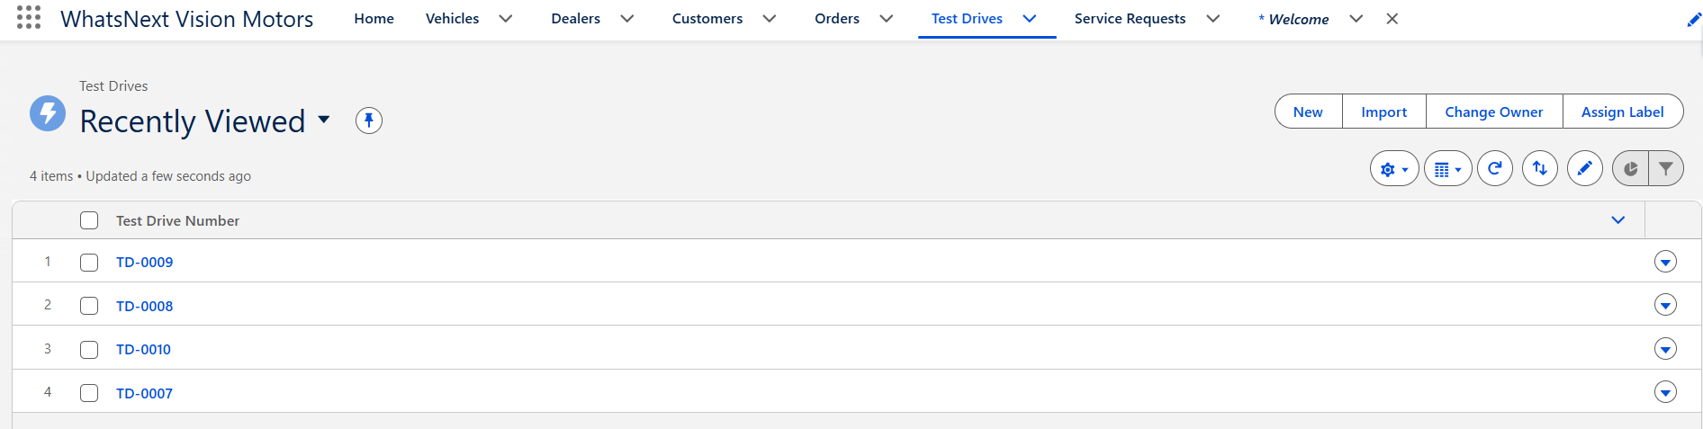

Service Request
- Service Request Number
- Project Customer
- Vehicle
- Dealer
- Status
- Request Details
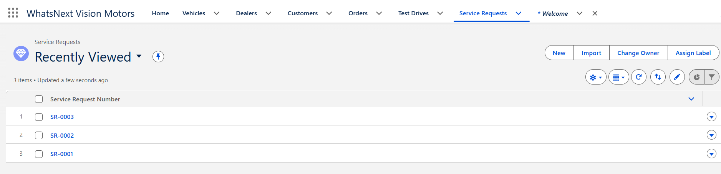
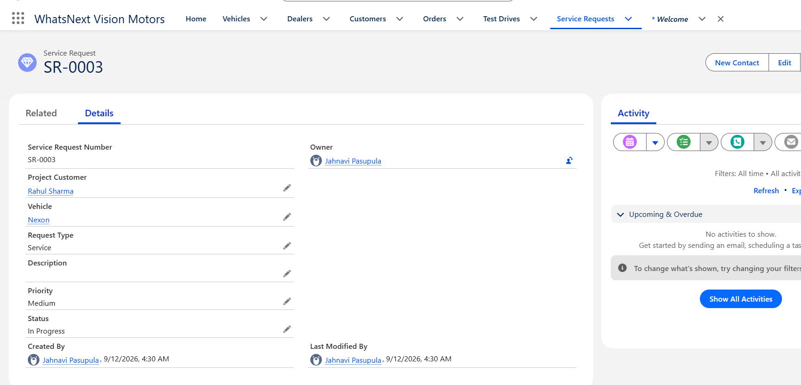

9. Vehicle Inventory Management
Vehicle records contain model, brand, price, stock quantity, and availability. The project uses stock quantity to determine whether a vehicle is Available or Out of Stock.
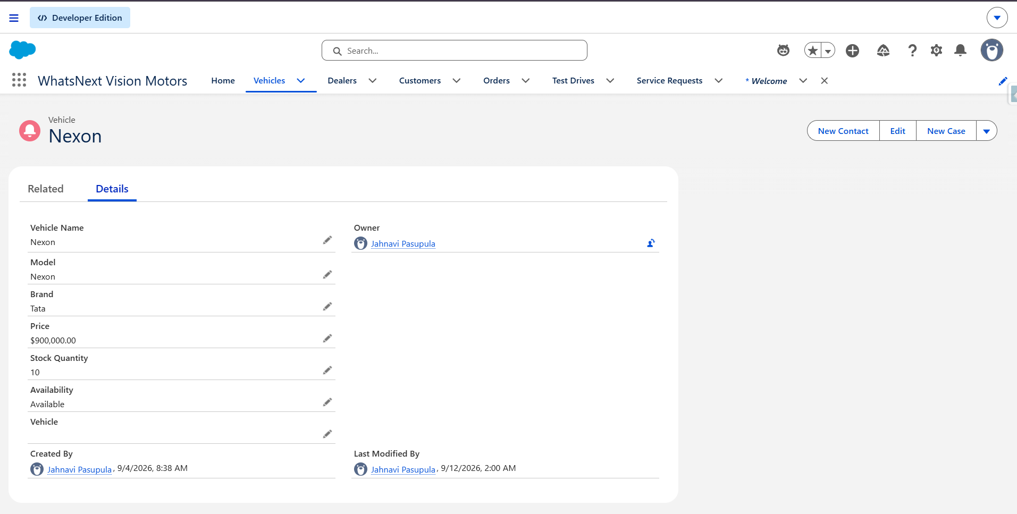

10. Order Management
Orders connect the project customer, vehicle, and dealer. Each order also stores quantity, order date, status, and total amount.
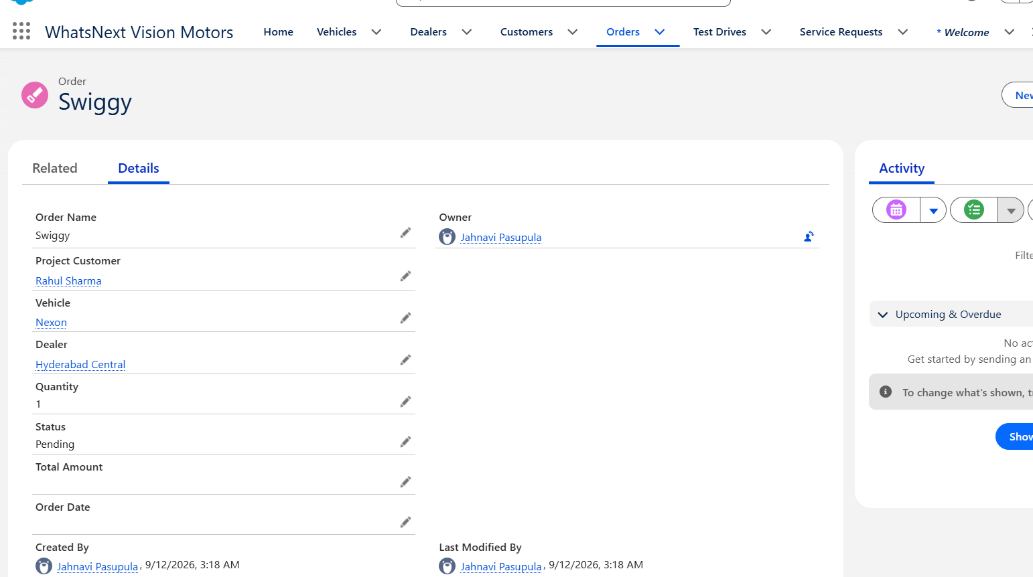

11. Stock Validation using Apex Trigger
An Apex trigger calls OrderTriggerHandler before an order is inserted. The handler checks the selected vehicle's Stock Quantity. If stock is zero or unavailable, the order is blocked with a validation message.
Expected validation message:
"This vehicle is currently out of stock. Order cannot be placed."
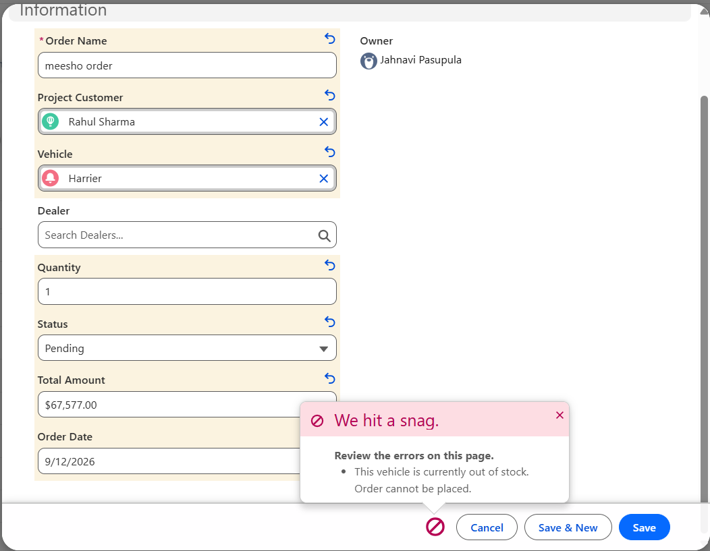
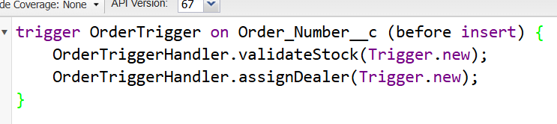
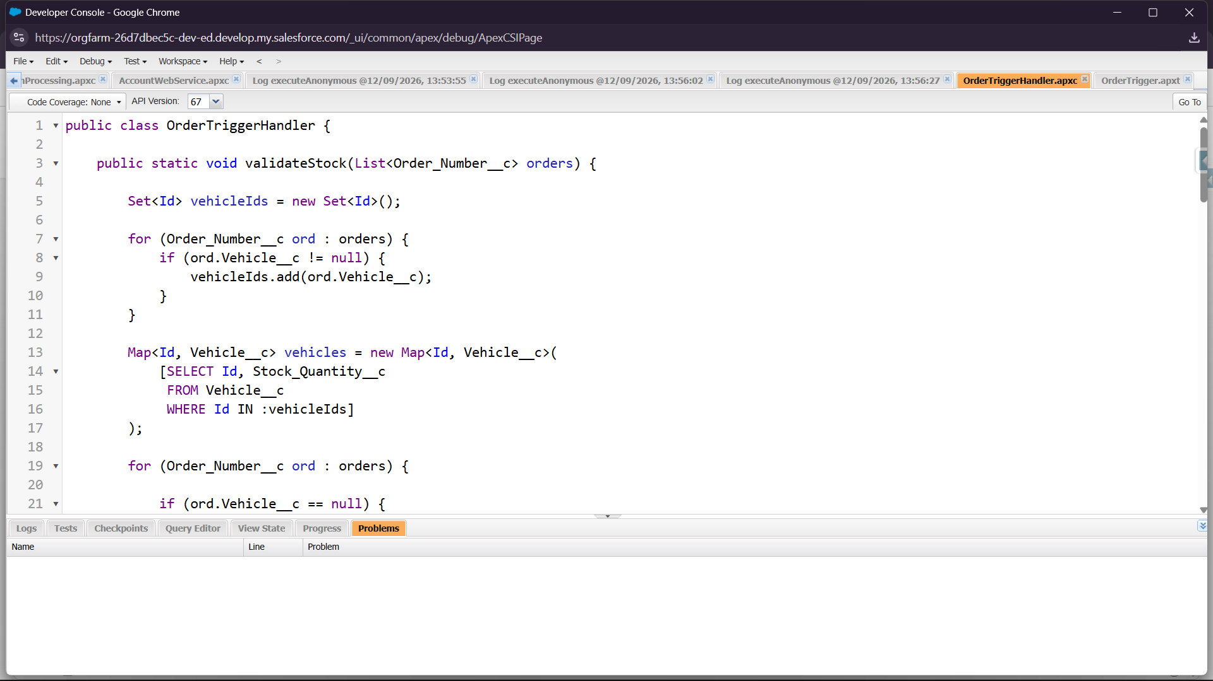

12. Automatic Nearest Dealer Assignment
The OrderTriggerHandler retrieves the customer's latitude and longitude and compares them with dealer location coordinates. The dealer with the shortest calculated coordinate distance is assigned automatically to the order.
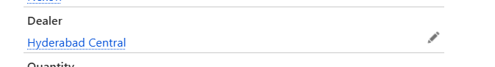
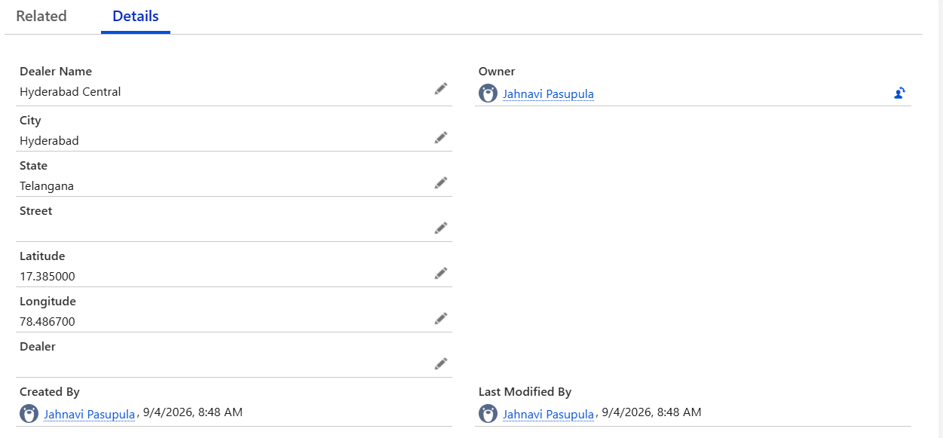

13. Test Drive Management
Customers can be associated with a vehicle, dealer, scheduled date and time, and test drive status. Scheduled test drives are processed by a record-triggered Flow.

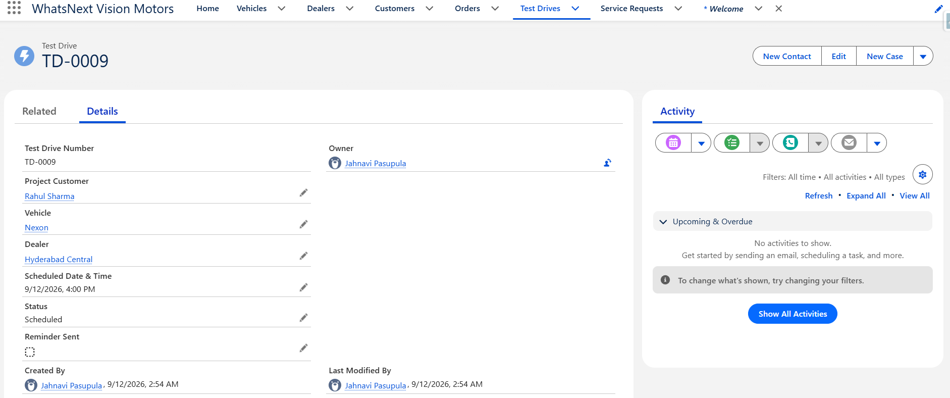

14. Test Drive Reminder Automation
The Test Drive Reminder New Flow uses a scheduled path based on Scheduled Date & Time. The reminder is configured to run one hour before the scheduled test drive and send an email to the customer's email address.
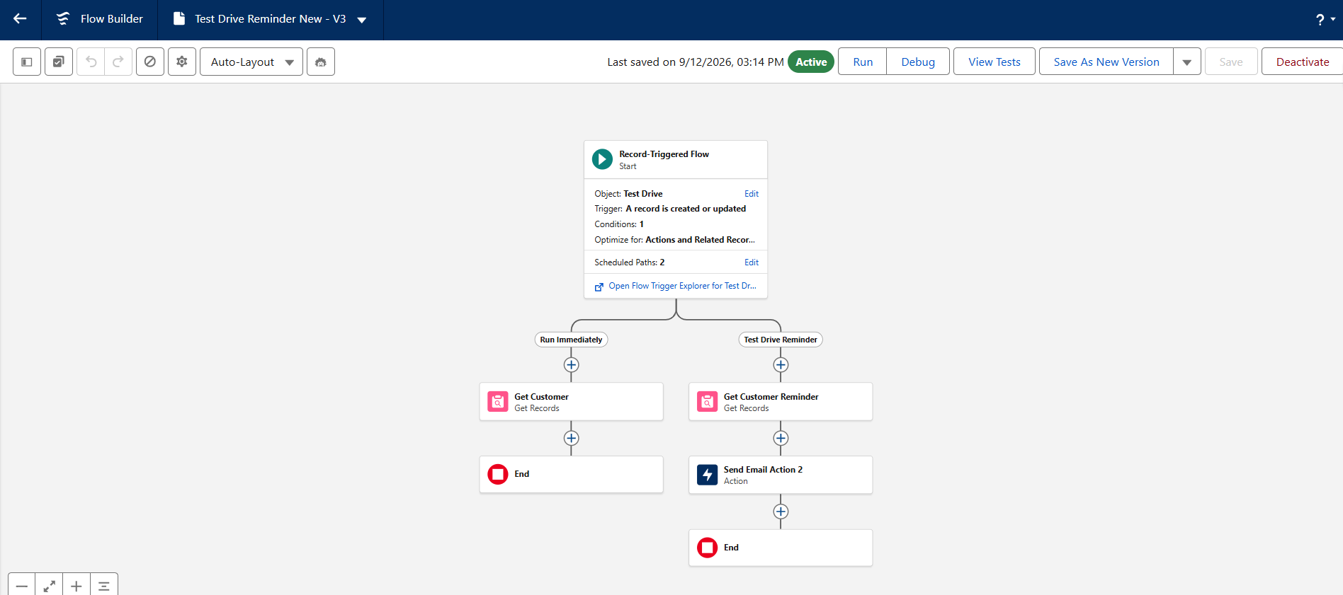

15. Service Request Automation
A record-triggered Flow named Service Request Status Flow automatically updates the status of a newly created service request to In Progress.
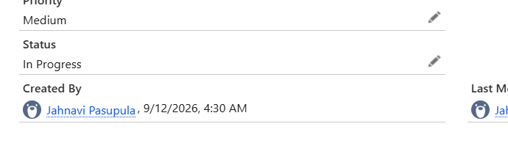
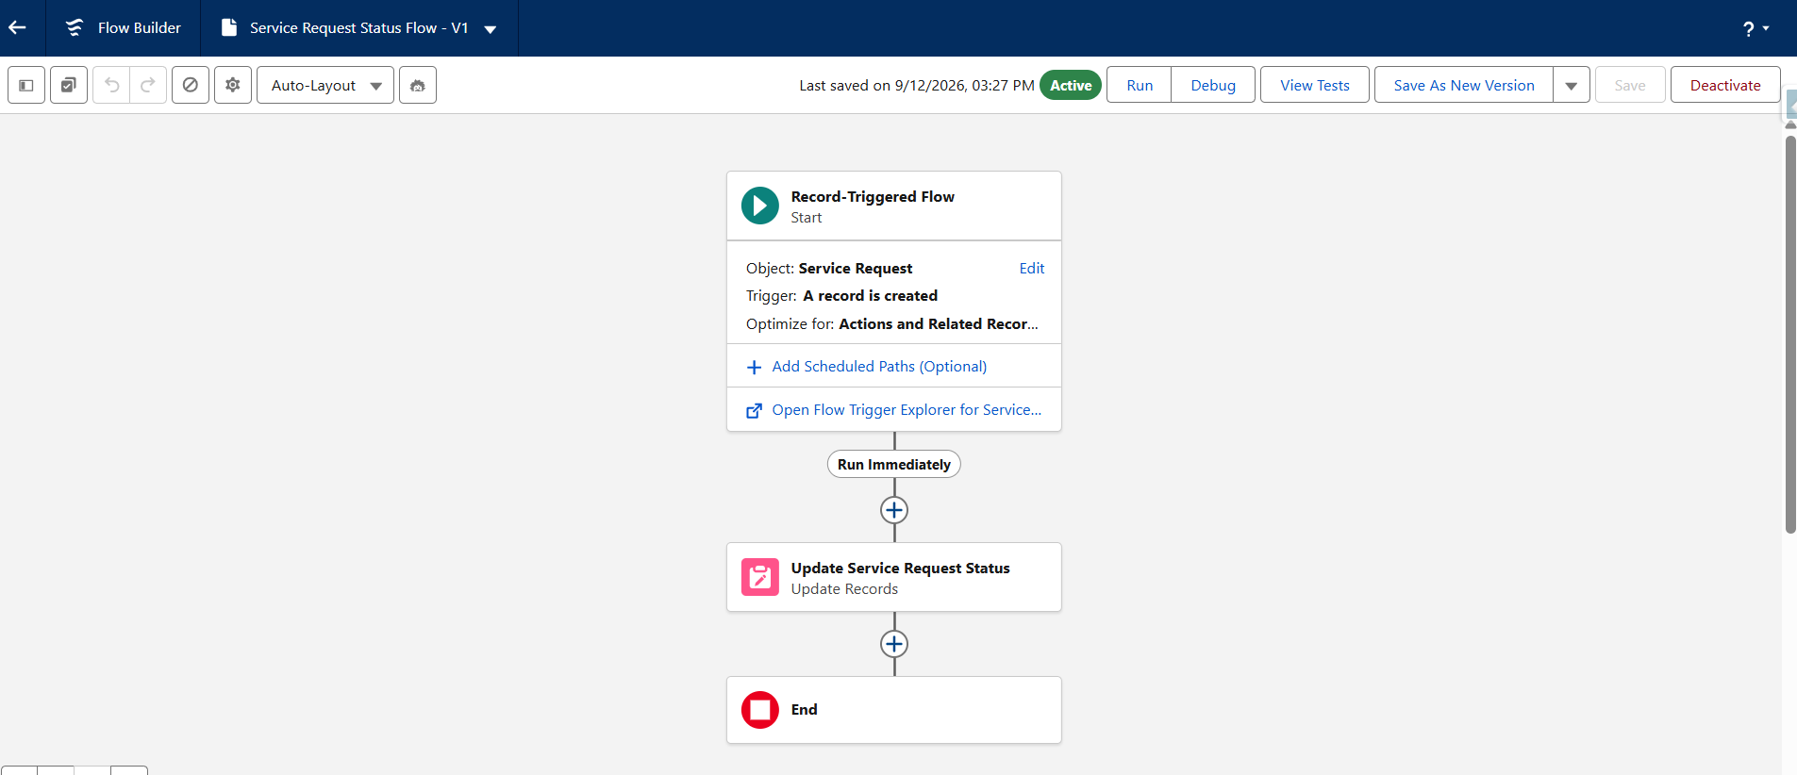

16. Batch Apex – Vehicle Stock Update
VehicleStockBatch processes vehicle records in batches and updates the Availability field. Vehicles with stock greater than zero are marked Available; vehicles with zero stock are marked Out of Stock.
global class VehicleStockBatch implements Database.Batchable<SObject> {
global Database.QueryLocator start(Database.BatchableContext bc) {
return Database.getQueryLocator(
'SELECT Id, Stock_Quantity__c, Availability__c FROM Vehicle__c'
);
}
global void execute(Database.BatchableContext bc, List<Vehicle__c> vehicles) {
for (Vehicle__c vehicle : vehicles) {
if (vehicle.Stock_Quantity__c != null &&
vehicle.Stock_Quantity__c > 0) {
vehicle.Availability__c = 'Available';
} else {
vehicle.Availability__c = 'Out of Stock';
}
}
update vehicles;
}
global void finish(Database.BatchableContext bc) {
}
}

17. Scheduled Apex – Daily Vehicle Stock Update
VehicleStockScheduler schedules the VehicleStockBatch to execute automatically. The configured job runs daily to keep vehicle availability synchronized with stock quantity.
VehicleStockScheduler Code:
global class VehicleStockBatch implements Database.Batchable<SObject> {
global Database.QueryLocator start(Database.BatchableContext bc) {
return Database.getQueryLocator(
'SELECT Id, Stock_Quantity__c, Availability__c FROM Vehicle__c'
);
}
global void execute(Database.BatchableContext bc, List<Vehicle__c> vehicles) {
for (Vehicle__c vehicle : vehicles) {
if (vehicle.Stock_Quantity__c != null &&
vehicle.Stock_Quantity__c > 0) {
vehicle.Availability__c = 'Available';
} else {
vehicle.Availability__c = 'Out of Stock';
}
}
update vehicles;
}
global void finish(Database.BatchableContext bc) {
}
}
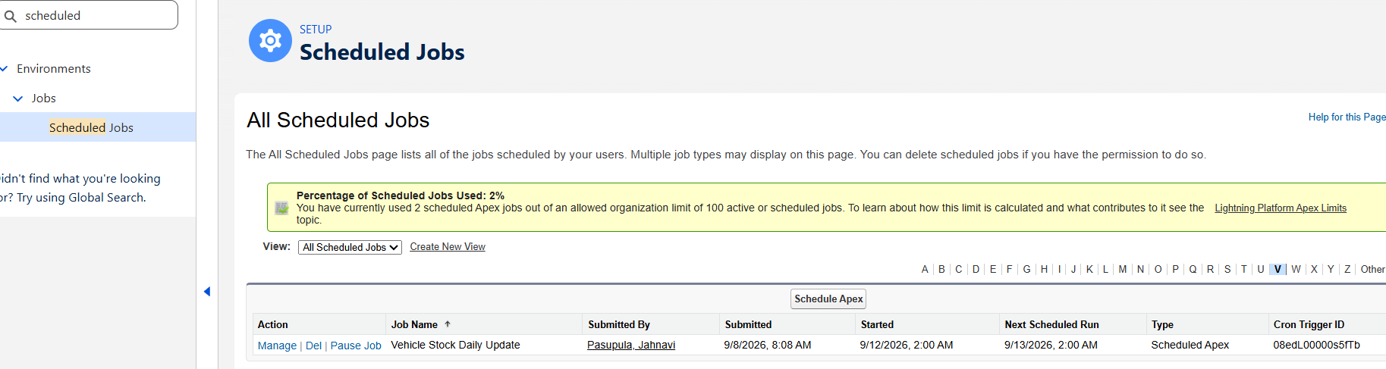

18. Batch Apex – Order Status Processing
OrderStatusBatch processes Pending orders and checks the stock of their selected vehicles. If stock is available, the order status is changed to Confirmed; otherwise it remains Pending.
ORDER STATUS BATCH CODE:
global class OrderStatusBatch implements Database.Batchable<SObject> {
global Database.QueryLocator start(Database.BatchableContext bc) {
return Database.getQueryLocator(
'SELECT Id, Vehicle__c, Status__c FROM Order_Number__c ' +
'WHERE Status__c = \'Pending\''
);
}
global void execute(Database.BatchableContext bc, List<Order_Number__c> orders) {
Set<Id> vehicleIds = new Set<Id>();
for (Order_Number__c ord : orders) {
if (ord.Vehicle__c != null) {
vehicleIds.add(ord.Vehicle__c);
}
}
Map<Id, Vehicle__c> vehicles = new Map<Id, Vehicle__c>(
[SELECT Id, Stock_Quantity__c
FROM Vehicle__c
WHERE Id IN :vehicleIds]
);
for (Order_Number__c ord : orders) {
Vehicle__c vehicle = vehicles.get(ord.Vehicle__c);

if (vehicle != null && vehicle.Stock_Quantity__c > 0) {
ord.Status__c = 'Confirmed';
} else {
ord.Status__c = 'Pending';
}
}
update orders;
}
global void finish(Database.BatchableContext bc) {
}
}

19. Scheduled Stock and Order Notifications
StockOrderNotificationScheduler checks for vehicles with zero stock and orders that are still Pending. If either condition exists, the scheduler sends an email notification to the current Salesforce user's email address.
STOCK/ORDER NOTIFICATION SCHEDULER CODE:
global class StockOrderNotificationScheduler implements Schedulable {
global void execute(SchedulableContext sc) {
List<Vehicle__c> outOfStockVehicles = [
SELECT Name, Model__c, Stock_Quantity__c
FROM Vehicle__c
WHERE Stock_Quantity__c = 0
];
List<Order_Number__c> pendingOrders = [
SELECT Name, Status__c
FROM Order_Number__c
WHERE Status__c = 'Pending'
];
if (outOfStockVehicles.isEmpty() && pendingOrders.isEmpty()) {
return;
}
User currentUser = [
SELECT Email
FROM User
WHERE Id = :UserInfo.getUserId()
];
String body = 'WhatsNext Vision Motors Notification\n\n';
if (!outOfStockVehicles.isEmpty()) {
body += 'STOCK REPLENISHMENT REQUIRED:\n';
for (Vehicle__c vehicle : outOfStockVehicles) {
body += '- ' + vehicle.Model__c +
' | Stock: ' + vehicle.Stock_Quantity__c + '\n';
}
body += '\n';
}
if (!pendingOrders.isEmpty()) {
body += 'PENDING ORDER PROCESSING:\n';
for (Order_Number__c orderRecord : pendingOrders) {
body += '- Order: ' + orderRecord.Name +
' | Status: ' + orderRecord.Status__c + '\n';
}
}
Messaging.SingleEmailMessage email =
new Messaging.SingleEmailMessage();
email.setToAddresses(new String[] { currentUser.Email });
email.setSubject('WhatsNext Vision Motors - Stock & Order Notification');
email.setPlainTextBody(body);
Messaging.sendEmail(
new Messaging.SingleEmailMessage[] { email }
);
}
}

20. Testing and Results
The following test cases can be documented.
Out-of-stock order: Input – Attempted to order Harrier with stock quantity 0. Result – Order blocked with out-of-stock error.
In-stock order: Input – Created an order for an available vehicle. Result – Order created successfully.
Nearest dealer assignment: Input – Created an order with a project customer and vehicle. Result – Dealer was automatically assigned.
Vehicle stock batch: Input – Executed VehicleStockBatch. Result – Availability updated according to stock quantity.
Pending order processing: Input – Executed OrderStatusBatch. Result – Orders with available stock changed to Confirmed.
Test drive reminder: Input – Scheduled a test drive. Result – Reminder Flow configured to send email one hour before the scheduled time.
Service request automation: Input – Created a service request. Result – Status changed automatically to In Progress.

21. Scheduled Jobs
Configured scheduled processes include:
- Vehicle Stock Daily Update
- Daily Stock Order Notification

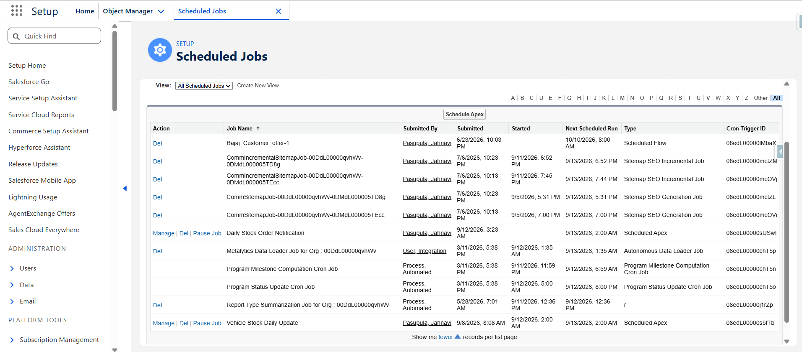

22. Project Workflow
Customer information is maintained in Salesforce. When a customer places an order, the system validates vehicle stock and automatically assigns a nearby dealer. Vehicle inventory is periodically checked using Batch Apex and Scheduled Apex. Pending orders are processed when stock becomes available. Test drives receive automated reminder emails, while service requests are automatically moved to In Progress.

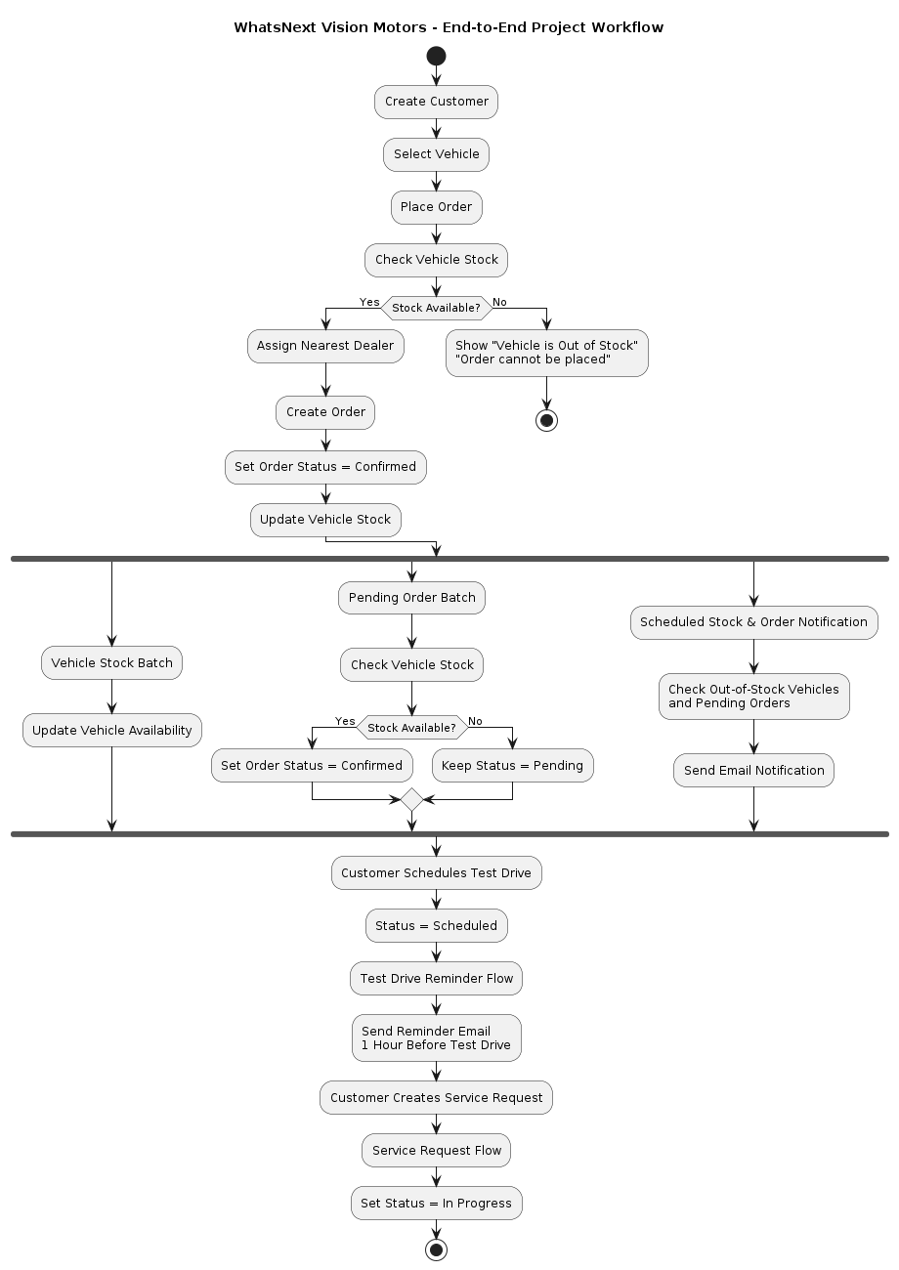

23. Learning Outcomes
- Understanding Salesforce CRM and Lightning applications.
- Creating custom objects, fields, tabs, and relationships.
- Designing Salesforce data models.
- Building record-triggered Flows and scheduled paths.
- Developing Apex classes and triggers.
- Implementing trigger-handler architecture.
- Using SOQL for querying related Salesforce records.
- Developing Batch Apex for bulk processing.
- Scheduling Apex jobs for periodic automation.
- Implementing automated email notifications.
- Testing Salesforce functionality using real project records.

25. Future Enhancements
- Use a more advanced geographic distance calculation or Salesforce geolocation fields for dealer matching.
- Create dashboards for sales, inventory, test drives, and service requests.
- Add role-based access and sharing rules for different dealership users.
- Integrate external vehicle or inventory systems.
- Add customer self-service capabilities through Experience Cloud.
- Add richer reporting and analytics for dealership performance.

26. Demo Link
The project demonstration is provided through a hosted demo video. Paste the final Google Drive or other accessible demo URL below.
G:\My Drive\Salesforce SkillWallet Project.mp4

27. GitHub Repository
The GitHub repository contains the project documentation and selected implementation files such as Apex classes, trigger code, and supporting project information.

28. Salesforce Trailhead Profile
Salesforce Trailhead Profile:
https://www.salesforce.com/trailblazer/dyjyzvcoc58m0ilgdf

29. Conclusion
WhatsNext Vision Motors demonstrates how Salesforce can be used to build a structured CRM solution for vehicle dealership operations. The project combines Salesforce data modeling, Lightning applications, Flow automation, Apex triggers, Batch Apex, Scheduled Apex, and email notifications to reduce manual work and improve order, inventory, test-drive, and service-request management.

Thankyou.

